- 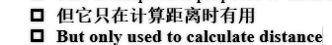
It only appeared in the calculation of total distance.

- P13 variable type 需要在前面加上说明
- 我的部分我就不做主观修改了
Thus, due to the similarity between both processes, …; the aisles are maximally utilized in terms of parallelity.
- 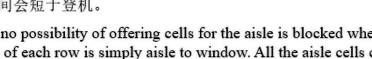
for 前面最好加逗号
缺个右括号
Once united in magnitudes, the dissatisfaction index can rather equally reflect the three aspects of passengers’ satisfaction.
- 模拟结果部分我认为可以等会画一张python柱状图，然后同时放上这张图
- 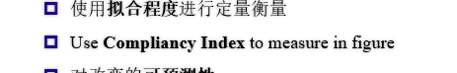
in concrete figures
- 
Predictability
- 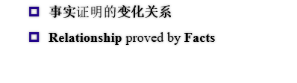
内容修改：事实->结论与模型
Facts-> Claims and our model

